|  |  |
| --- | --- |
| **Exp no: 03**  **Date:** | **Introduction to JavaServelet Progra** |

**Aim:**

To write a **Java Servlet** program that displays **"Hello, World!"** on a web browser when the servlet is accessed via an HTTP request.

**Algorithm:**

* Start by importing necessary packages (javax.servlet.*,javax.servlet.http.*, java.io.*).
* Create a class that extends HttpServlet.
* Override the doGet() method to handle GET requests.
* Set the content type of the response to "text/html".
* Use a PrintWriter to write "Hello, World!" to the browser.
* Compile the servlet and deploy it to a servlet container like Apache Tomcat.
* Access the servlet through a web browser using the correct URL mapping.

**Java CODE:**

Hello World:

package main;

import java.io.IOException;

import javax.servlet.ServletException;

import javax.servlet.annotation.WebServlet;

import javax.servlet.http.HttpServlet;

import javax.servlet.http.HttpServletRequest;

import javax.servlet.http.HttpServletResponse;

@WebServlet("/hello")

public class HelloWorldServlet extends HttpServlet {

    private static final long serialVersionUID = 1L;

    @Override

    protected void doGet(HttpServletRequest request, HttpServletResponse response)

            throws ServletException, IOException {

        response.setContentType("text/html");

        response.getWriter().println("<h1>Hello, World!</h1>");

    }

}

**HTML CODE:**

<!DOCTYPE html>

<html lang="en">

<head>

    <meta charset="UTF-8">

    <meta name="viewport" content="width=device-width, initial-scale=1.0">

    <title>Welcome</title>

</head>

<body>

    <h2>Welcome to the Hello World Servlet Application</h2>

    <p>Click the button below to see the "Hello, World!" message.</p>

    <form action="hello" method="get">

        <button type="submit">Go to Servlet</button>

    </form>

</body>

</html>

**Output:**

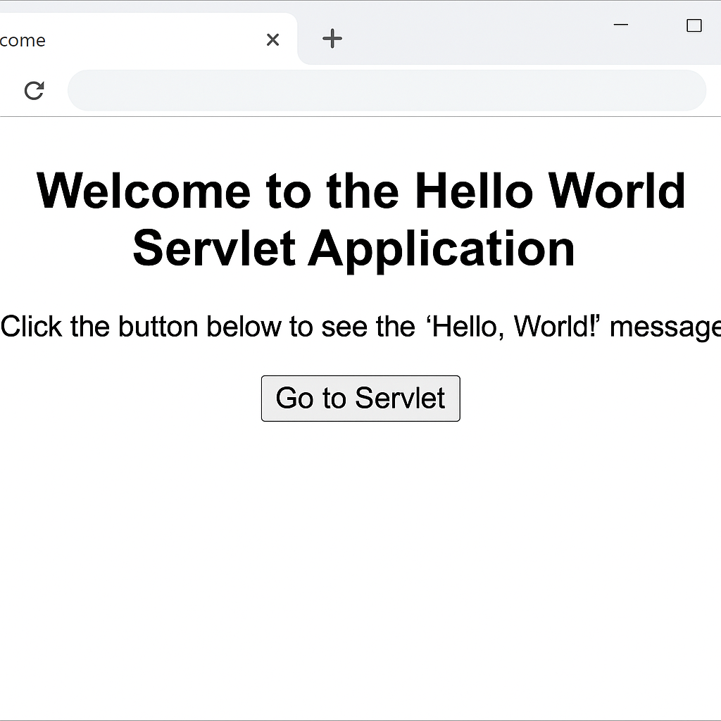

**Result:**

Thus the required web page has been successfully implemented using HTML and CSS.